**Software – Quality(Test) and Deployment(DevOps)**

**Software basics**

***Computer***

A computer is a programmable device that **stores, retrieves, and processes data.**

***Computer Architecture:***

is a **set** of **rules** and **methods** that **describe** the **functionality**, **organization**, and **implementation** of **computer systems.**

In other definitions computer architecture involves **instruction set, architecture design, logic design, and implementation.**

***Types of Computer Architecture:***

**1. Von-Neumann Architecture**

proposed by **john von-Neumann**.

**Data** and **instructions** are **stored** in **a single read/write memory** within the computer system.

***Each memory has multiple locations and each location has a unique address.***

We can **address the contents of memory by its location** irrespective of what type of data and instructions are present in the memory, because of which we can read or write any data and instructions.

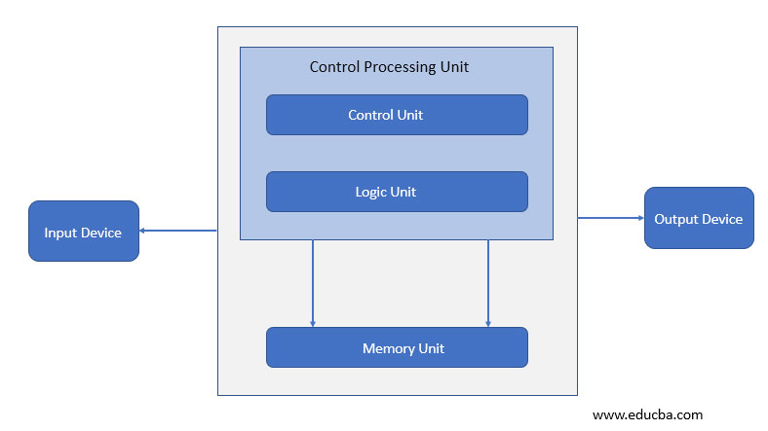

There is a **bus** (address bus/data bus/control bus) used for the **instruction** and **data code execution**. Input device takes data or instruction and the **Central processing unit (CPU) performs one operation at a time**, either fetching data or instruction in/out of the memory. Once the operation is done it is sent to the output device. **Control and logic units for processing operations are within the central processing unit.**

**2. Harvard Architecture**

**data and code is present in different memory blocks.**

A separate memory block is needed for data and instruction. Data can be accessed by one memory location and instruction can be accessed by a different location. It has **data storage entirely contained within the central processing unit (CPU).** A **single set of clock cycles** is required. The pipeline is possible. It is **complex to design**.

**CPU can read and write instructions and process data access.**

Harvard architecture has **different access codes and data address spaces** that is, the instruction address zero is not the same as data address zero. Instruction address zero identifies 24-byte value and data address zero identifies 8-byte value which is not the part of the 24-byte value.

**Modified Harvard architecture** is like a Harvard architecture machine and it has a **common address space for the separate data and instruction cache.** It has **digital signal processors** that will execute small or highly audio or video algorithms and it is reproducible. **Microcontrollers** have a **small number of programs** and **data memory** and it **speeds up** the processing by **executing** **parallel instructions and data access.**

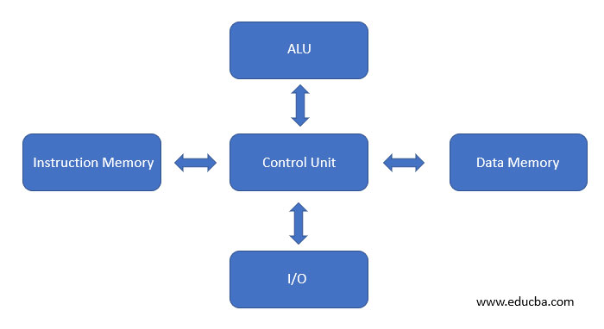

**3. Instruction Set Architecture**

it has a **set of instructions** that the **processor understands.** It has **two instruction set one is RISC (reduced instruction set computer) and the second is CISC (complex instruction set computer).**

Reduced instruction set computer architecture was realized in the 90’s by IBM. **Instruction** has **multiple address modes**, but programs do not use all of them that is the reason multiple address modes were reduced. This helps the **compiler to easily write the instructions**, **performance is increased.**

**Complex instruction set architecture** is the **root of compilers** because earlier compilers were not there to write programs, to ease programming instructions are added.

**4. Microarchitecture**

Microarchitecture is known as **computer organizations** and it is the way when **instruction set architecture is a built-in processor**. Instruction set architecture is implemented with various **microarchitecture** and it varies because of changing technology.

**5. System Design**

The name defines itself, the **design will satisfy user requirements** such as architecture, module, interfaces and data for a system and it is connected to product development. It is the process of taking marketing information and creating product design to be manufacture. **Modular systems are made by standardizing hardware and software.**

***Computer Organization:***

**Computer Organization** is concerned with the **structure** and **behaviour** of a **computer** system as seen by the user.

**Processors** are the **heart** of the computer which **executes the programs.**

**Control Unit and Execution Unit in a Processor both are independent to each other.**

**ALU is part of Execution Unit.**

**Control Unit fetch Instructions to the processors through Bus and decodes it .**

**Instructions in Memory are in Machine Language.**

**Programs** are **stored** inside **the memory.**

**I/O** for **read or write data/instructions.**

**All components are connected through a Bus.**

***Software:***

the **programs** and other **operating information** used by a computer.

***Web application:***

A web application is an **application software** that **runs on a web server**, unlike **computer-based software programs** that are stored locally on the **Operating System of the device.**

***Web applications are accessed by the user through a web browser with an active internet connection.***

*(Web app) is an application program that is stored on a remote server and delivered over the Internet through a browser interface.*

***Server:***

***A Server is a centralized computer which offers A specific service via Internet / LAN.***

Example: Web Server, Email Server, DB Server, File Server.

**ECC (Error Correcting Code) RAM** is used **in processors of Servers**.

ECC protects against memory errors so that it detects data is processed correctly.

*Server needs an OS which is robust and stable with redundant power supply.*

***A server is a role that a computer takes, it is not a physical machine .***

*Desktop CPU supports only one processor, whereas Server CPU supports multiple processors.*

*Server processors have larger cache memory and higher core count.*

*Server will have hot swappable hard drives in a RAID configuration.*

*(RAID copies data on multiple disks.)*

***Proxy server:***

**Proxy servers** act as a **firewall** and **web filter**, provide **shared network connections,** and **cache data** to speed up common requests.

*A good****proxy server****keeps users and the internal network protected from the bad stuff that lives out in the wild internet.*

*Retrieves data on the internet on behalf of users.*

***Benefits:***

1. ***Privacy****: allows to surf the internet anonymously as it hides the clients ip address.*
2. ***Speed****: cached webpage DB in proxy server,*
3. ***Saves bandwidth.***
4. ***Activity logging.***

***Encrypt data for data security by using VPN which hides ip address and encrypt the data.***

***Browser:***

a **computer program** with a **graphical user interface** for **displaying HTML files, used to navigate the World Wide Web.**

***“Browser displays the webpage”*** *–* URL is required to fetch the resource(GET method),

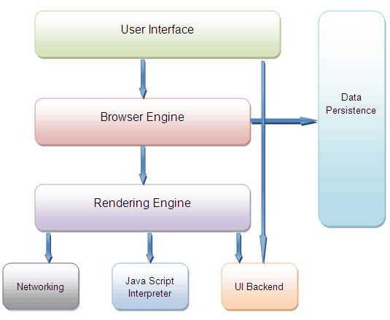

**Browser**

* parses HTML file.
* Fetches linked resources
* Builds the document
* Renders the document
* Publish the DOM.
* **Runs Java script using the DOM.**

**Working of a browser with components:**

Send a request over the network to a server and in turn server responds with web contents, browser interprets the content returned and displays the page.

**Rendering engine**- displaying the visual representation of the webpage.

Constructs the page by applying right structure and colors.

It takes HTML + CSS documents and displays the interpretation of both.

HTML for markup and CSS is to animate the content.

**Browser Engine**

Acts as a **Marshall** by directing actions b/w **UI** and **rendering Engine** and external communication b/w **rendering Engine** with **Server**.

**Network**  provides requested document to rendering engine.

**Java Script for interactive logic and functionality using Java Script Interpreter.**

**Java Script Interpreters -**

**Chakra – MS Edge**

**Spidermonkey - Firefox**

**V8- Chrome**

**Data Storage** – **Cookies** and **Local Storage.**

**Rendering engines are different for different browsers so webpages look different in different browsers**

**Chrome and Opera uses blink.**

**Safari uses Webkit**

**Firefox uses Gecko**

1. Rendering Engine reads HTML and creates a DOM content tree -Document Object Model - object representation of html document.

DOM Tree is made up of DOM nodes.

Nodes can be Images, Text blocks, buttons or any elements

1. All CSS styles associated with the DOM nodes are parsed by the engine.
2. Render Tree is created with new Styling and nodes.
3. Layout process- Each node is positioned on layout with respective coordinates.
4. UI Backend layer traversed the Render Tree and paints each node.

***Client Server architecture:***

***Request by a client and response by a Server.***

*Different* ***Service*** *by a Different* ***Server*** *having Different* ***Software*** *providing Different* ***protocols*** *and each protocol having Different* ***port numbers.***

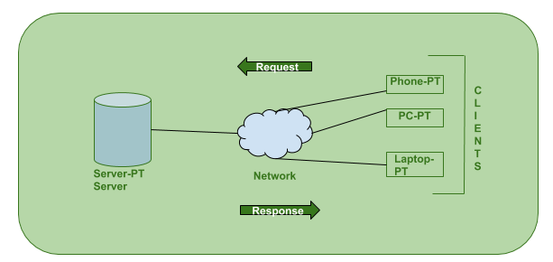

***IP address:***

An Internet Protocol address (IP address) is a **numerical label** assigned to **each device connected to a computer network that uses the Internet Protocol for communication.**

An IP address serves two main functions:

1. **host or network interface identification** and
2. **location addressing.**

**Types:** 1. **IPV4** -32 bits, 4 binary numbers separated by **.**

2. **IPV6** -128 bits **8 Hexadecimal numbers** separated by **:**

**Classification:**

1. **Dynamic** – ISP provides from available range.

2. **Static** – never change, permanent IP address, **DNS Server assigns** this.

Includes- Continent, Country, Place and which ISP provides the Internet.

**Less secure and easy to track.**

Also known as **dedicated ip.**

**Note:**

**A Static IP is assigned by a user manually.**

***Network:***

A network is a **collection** of computers, servers, mainframes, network devices, peripherals, or other devices connected to one another  
to **allow** the **sharing of data.**

Common types of area networks are:  
***Internet***  
LAN - Local Area Network.  
WAN - Wide Area Network.  
WLAN - Wireless Local Area Network.  
MAN - Metropolitan Area Network.  
SAN - Storage Area Network, System Area Network, Server Area Network, or sometimes Small Area Network.

***Internet - working***

Mode1:

Data from data centres are sent to Satellites in the form of signals via Antenna. These signals from satellites are sent to local devices via another Antenna. These mode is not preferred as latency is more that is delayed transmission of data.

Mode2:

Through **Optical Fibre Network**

Data in Data Centres are stored in **SSD** **(Solid State Device).**

**SSD access the** internal memory of the server.

***OSI Model:***

The **Open Systems Interconnection** model (OSI model) is a conceptual model that characterises and standardises the **communication functions**  
of a **telecommunication** or **computing system** **without** regard to its underlying **internal structure and technology.**  
Its **goal** is the **interoperability** of diverse communication systems with **standard communication protocols.**The model **partitions a communication system into abstraction layers.**

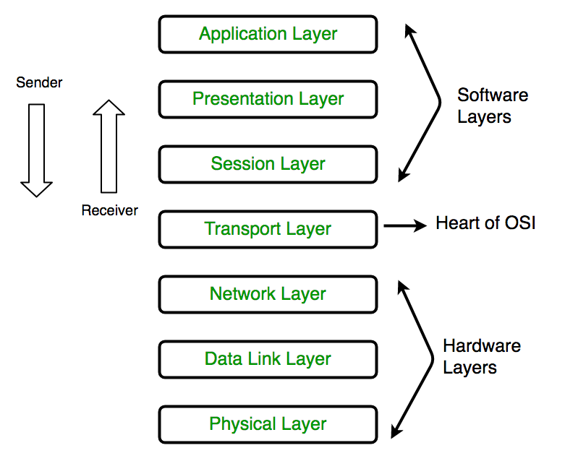

**OSI** model is to **standardize communication** over the **network**.

**Physical** - carry **data across physical components**.

**Data Link** - **physical addresses** are added to the **Data**.

**Network** - **IP address and routing.**

**Transport**- Transport protocols - **TCP / UDP/ Source and destination**

**Port numbers. TCP - Error handling and sequencing.**

**Session** - **establishing and terminating connections** b/w devices.

**Presentation** - **Data format and encryption.**

**Application** - **application and user communicates.**

***TCP/IP:***

A **set** of **rules** that **governs** the **connection** **of computer systems to the internet.**

**TCP/IP** is composed of **layers**, each layer is responsible for performing certain **operations** on the **data it receives** and passing it to the higher layers.

Each layer deals with certain **issues** related to the **transmission of data** and renders certain **services** to its higher layers.

When Transmission Control Protocol **(TCP) couples with IP**, you get the ***internet highway traffic controller.***

TCP and IP work together to transmit data over the internet but at different levels. Since **IP does not guarantee reliable packet delivery** over a network, **TCP** takes the charge of making the **connection reliable.**

***Note:***

**TCP/IP** is a **set of data transfer protocols** used by **modern data networks.**

**Data network** - a group of computers and other devices that communicate over a **shared medium.**

A network protocol is a set of rules for how applications intercommunicate.

Protocols that make TCP/IP will define:

* How data is transmitted across a n/w.
* How data should be formatted so other networked systems can understand it.

**Port number:**

a port is a communication endpoint.

***DNS - Domain Name System:***

Computers will have **numbers(ip address)** instead of names which will be used to **get identified over a network.**

**DNS – resolves names to numbers (domain names to ip address).**

If browser/OS cannot find the ip address for the name (URI), query will be sent to **“Resolver”** which is nothing but the **ISP(Internet Service Provider)**

If ISP cannot find the query it will be forwarded to **“Root Server”**

**Note:** ***13 sets of “Root Server” are placed in the world,*** operated by 12 different organizations. Each set has unique IP address.

“Root Server” will direct the resolver to **“TLD Server”** [**Top Level Domain** ]

[TLD Server – stores info of top-level domains like .com,.org,.net]

TLD Server will direct the resolver to **“Authoritative Name Servers”.**

Once ip address is obtained, Resolver stores it in its cache, so that it can be fed against any further request for the same URI from the browser.

**VPN – Virtual Private Network**

Is used to **encrypt the data** and add **a layer of privacy to protect the identity.**

***Server access the internet on behalf of the client.***

VPN is not an Internet connection; it is ***a secure way to access the Internet.***

**DHCP: Dynamic Host Configuration Protocol**

**Note:**

**IP Conflict :** Multiple computers(machines) having same ip address which makes those computers not have network access.

Dynamic IP is obtained by DHCP Server automatically.

DHCP assigns a Computer the following items:

**IP address**

**Subnet mask**

**Default Gateway**

**DNS Server**

DHCP assigns an IP address to Computer in the network from its “SCOPE”

***“SCOPE” – A range of IP addresses that a DHCP Server can handout.***

| URL | URI |
| --- | --- |
| URL is used to **describe** the **identity of an item.** | URI provides a **technique for defining the identity of an item.** |
| URL links a web page, a component of a web page or a program on a web page with the help of **accessing methods like protocols.** | URI is used to **distinguish one resource from other regardless of the method used.** |
| URL provides the **details about what type of protocol is to be used.** | URI **doesn’t contains the protocol specification.** |
| URL is a type of URI. | URI is the superset of URL. |

**HTTP:**

The Hypertext Transfer Protocol (HTTP) is an **application protocol** for distributed, collaborative, **hypermedia** information systems.

HTTP is the foundation of **data communication** for the **World Wide Web,**

where **hypertext documents** include **hyperlinks** to other **resources** that the user can easily access.

**HTTP status codes:**

Status codes are **issued by a server** in **response to a client's request made to the server.**

It includes codes from **IETF Request for Comments (RFCs**), other **specifications**, and some additional codes used in some common applications of the HTTP.

The **Internet Assigned Numbers Authority (IANA**) maintains the **official registry of HTTP status codes.**

The **first digit of the status code defines the class of response**, while the last two digits do not have any classifying or categorization role.

There are **five classes** defined by the standard:

**1xx informational response** – the **request** was **received**, **continuing process**

**2xx successful** – the **request** was **successfully received**, **understood**, and **accepted**

**3xx redirection** – **further action needs to be taken in order to complete the request**

**4xx client error** – the **request** contains **bad syntax** or cannot be fulfilled

**5xx server error** – the **server failed to fulfil an apparently valid request.**

**HTTP methods:**

**HTTP** defines a set of **request methods** to indicate the desired **action** to be **performed for a given resource.**

**The GET Method**

GET is used to **request data from a specified resource.**

GET requests can be **cached**

GET requests remain in the **browser history**

GET requests can be **bookmarked**

GET requests should **never be used** when dealing with **sensitive data**

GET requests have **length restrictions**

GET requests are **only** used **to request data (not modify).**

**The POST Method**

POST is used to **send data** to a server to **create/update** a resource.

POST requests are **never cached**

POST requests **do not remain** in the **browser history**

POST requests **cannot be bookmarked**

POST requests have **no restrictions on data length.**

**The PUT Method**

PUT is used to **send data to a server** to **create/update a resource.**

The difference between POST and PUT is that **PUT requests are idempotent.**

That is, calling the same PUT request multiple times will always produce the same result. In contrast,

calling a POST request repeatedly have side effects of creating the same resource multiple times.

The **HEAD Method**

HEAD is almost **identical to GET**, **but without the response body.**

*In other words, if GET /users returns a list of users, then HEAD /users will make the same request but will not return the list of users.*

HEAD requests are useful for checking what a GET request will return before actually making a GET request - like before downloading a large file or response body.

The **DELETE Method**

The DELETE method **deletes the specified resource.**

The **OPTIONS** Method

The OPTIONS method **describes** the **communication options for the target resource.**

**PUT v/s POST:**

**World Wide Web (WWW):**

is an **information system** where **documents** and other **web resources** are identified by **Uniform Resource Locators** may be **interlinked by hypertext,** and are accessible over the **Internet**.

**Hypertext:**

a **software system** that **links** topics on the screen to related information and graphics, which are typically accessed by a **point-and-click method.**

**programming language:**

A programming language is a **formal** language that **specifies a set of instructions** that can be used to produce various kinds of output.

Programming languages generally consist of **instructions for a computer.**

Programming languages can be used to create programs that **implement specific algorithms.**

[Algorithms - An algorithm is a procedure or formula for solving a problem,based on conducting a sequence of specified actions.]

A **computer program** can be viewed as an **elaborate algorithm.**

In mathematics and computer science, an **algorithm** usually means a **small procedure that solves a recurrent problem.**

The languages, machines,compilers and interpreters are only tools;

like brushes to painters.

The **computer version of programming – coding** and is mostly used for process automation/communication facilitation.

**Classification Of Software Programming languages:**

|  |  |
| --- | --- |
| **Imperative** | **Declarative** |
| instruct the computer **how** to do a task | tell the computer **what** to do |
| 1 . procedural - C  2. object-oriented languages– java | 1. functional languages -a program is constructed by composing **functions**.  functional- Haskell;   1. logic programming languages - a program is constructed through a **set of logical connections.**   Logic programming - Prolog. |
| Statically-typed  which typing is checked  (and usually enforced)  prior to running the program  (typically during a compile phase); | Dynamically-typed  defer type checking to runtime. |
| C, C++, and Java | Python, Ruby, JavaScript, and Objective-C |
| weak typing | strong typing |
| supports implicit type conversions | supports implicit type conversions. |

***Note:***

A language is statically typed if the type of a variable is known at compile time.

**Scripting language:**

A script or scripting language is a computer language with a **series of commands within a file** that is capable of **being executed without being compiled.**

Good examples of server-side scripting languages include Perl, PHP, and Python.

The best example of a client side scripting language is JavaScript.

Basically, all scripting languages are programming languages.

The theoretical difference between the two is that scripting languages do not require the compilation step and are rather interpreted.

Generally, *compiled programs run faster than interpreted programs because they are first converted to native machine code.*

**File archiver:**

A file archiver is a **computer program** that **combines** a number of files together into one archive file, or a series of archive files, for easier **transportation or storage.**

File archivers employ **lossless data compression** in their archive formats to **reduce the size of the archive.**

Basic archivers just take a list of files and concatenate their contents sequentially into archives.

The archive files need to store **metadata**, at least the names and lengths of the original files, if proper reconstruction is possible.

More advanced archivers store additional metadata, such as the original timestamps, file attributes or access control lists.

***Note:***

Metadata: Metadata is "data [information] that provides information about other data".

**Metadata types:**

**Descriptive metadata**

describes a resource for purposes such as **discovery** and **identification** include elements such as title, abstract, author, and keywords.

**Structural metadata**

**containers of data** and indicates how compound objects are put together,

for example, how pages are ordered to form chapters. describes the types, versions, relationships and other characteristics of digital materials.

**Administrative metadata**

information to help **manage a resource**, such as when and how it was created, file type and other technical information, and who can access it.

**Reference metadata**

describes the **contents** and **quality of statistical data.**

**Statistical metadata**

also describe **processes** that collect, process, or produce **statistical data.**

also called **process data.**

**Web Service:**

A web service is a way for two applications or electronic devices to communicate over a network.

**SOAP is a protocol. REST is an architectural style.**

SOAP stands for **Simple Object Access Protocol.**

REST stands for **Representational State Transfer.**

**REST API** has **no official standard** at all because it is an architectural style.

**SOAP API**, on the other hand, **has an official standard** because it is a **protocol.**

REST APIs uses multiple standards like HTTP, JSON, URL, and XML while SOAP APIs is largely based on HTTP and XML.

REST allows a greater variety of data formats, whereas SOAP only allows XML.

Coupled with JSON (which typically works better with data and offers faster parsing),

REST is generally considered easier to work with. REST is generally faster and uses less bandwidth.

**Platform = OS+ Processor**

**Compiler:** converts **Source code** to **Assembly language.**

**Assembly language:**

**instructions to Microprocessor**

ex: Store data in some location

**Assembler:**

Converts **Assembly language** to **Machine code in bits.**

**Microservice:**

**Traditional** Application development

**Modular** Application development

Deploy apps to user's machine

Deploy web apps to Server

**Monolithic architecture** - dis advantages

1. difficult to deploy big applications.

2. scalability - unpredictable traffic spikes (elastic servers to overcome this).

***Microservices are independent applications deployed independently on different servers and communicate each other over REST APIs and collectively makes a single application for end user.***

Each of these independent applications can be scaled independently in their respective servers.

**Microservices** - advantages

1. **Deployment flexibility**

**2. Technology flexibility**

3. **Scaled separately**

4. **Separate Business logic functions.**

5. **Language independent**

**Microservices** - dis advantages

1. **Deployment / Architecture complexity.**

2. **Service discovery.**

**DevOps:**

DevOps is Development and Operation's Collaboration, It's a **Union of Process, People and Working Product** that enable continuous integration and continuous delivery of value to our end users.

*DevOps accelerate the process to deliver applications and software services at high speed and high velocity.*

**Container:**

A container is a **standard unit of software** that **packages** up **code** and all its **dependencies** so the **application runs quickly** and **reliably** from one computing environment to another. ...

**Secure:** Applications are safer in containers and Docker provides the strongest default **isolation capabilities** in the industry.

**Container orchestration**

Container orchestration is the **automatic process** of managing or **scheduling** the work of individual **containers for applications** based on **microservices** within multiple clusters.

**Kubernetes**

- is an **open source system** for **automating deployment, scaling and management of containerized applications.**

**MVC architecture:**

The **Model-View-Controller (MVC)** is an **architectural pattern** that **separates** an **application** into **three main logical components**:

the model, the view, and the controller. Each of these **components** are built to handle **specific development aspects** of an application.

**Model**

The Model component corresponds to all the **data-related logic** that the user works with. This can represent either the data that is being transferred **between the View and Controller** components or any other business logic-related data.

For example, a Customer object will retrieve the customer information from the database, manipulate it and update it data back to the database or use it to render data.

**View**

The View component is used for all the **UI logic** of the application. For example, the Customer view will include all the UI components such as text boxes, dropdowns, etc. that the final user interacts with.

**Controller**

Controllers act as an **interface** between **Model and View** components to **process** all the **business logic** and incoming **requests**, **manipulate data** using the Model component and interact with the Views to render the final output. For example, the Customer controller will handle all the interactions and inputs from the Customer View and update the database using the Customer Model. The same controller will be used to view the Customer data.

**mock API**

A mock API server **imitates** a real API server by providing **realistic responses to requests.**

They can be on your **local machine** or the public **Internet**. **Responses** can be **static or dynamic,** and **simulate the data** the real API would return, matching the schema with data types, objects, and arrays.

**Software Environment**

A software environment for a particular application could include the **operating system, the database system, specific development tools or compiler.**

**Data Visualization**

is the **graphical representation of information and data.**

**Machine Learning**

Machine learning is a **method of data analysis** that **automates analytical model building.**

It is a **branch of artificial intelligence** based on the idea that **systems can learn from data, identify patterns** and make **decisions** with minimal human intervention.

**Business Analytics**

Business analytics is the **process of collating, sorting, processing, and studying business data, and using statistical models and iterative methodologies to transform data into business insights.**

**DSL and GPL**

**DSL:** A domain-specific language (DSL) is a computer language **specialized to a particular application domain.**

This is in contrast to a **general-purpose language (GPL),** which is broadly applicable across domains.

Simpler DSLs, particularly ones used by a **single application**, are sometimes informally called **mini- languages.**

A programming language designed for a particular purpose.

For example, **Tex** is a language used for **typesetting,** **SQL** is used to **query databases,** and **Mathematica** is used for **computations**.

A domain-specific language (DSL) is **more fine-tuned** to the **application environment** than a general-purpose programming language.

***Agile (*able to move quickly and easily*)***

**Software Number system:**

**Software Quality (Software Test)**

***Software testing is a process, to evaluate the functionality of a software application/product with an intent to find whether the developed software meet the specified requirements or not and to identify the defects to ensure that the product Is defect free in order to produce the quality product.***

***Functional Testing - Black Box***

Black-box testing is a method of software testing that examines the **functionality of an application** without peering into its internal structures or workings.

***Black Box Testing - types***

**1. Smoke Testing** - also known as **“Build Verification Testing**”, is a type of software testing that comprises of a **non-exhaustive set of tests** that aim at ensuring that the **most important functions work.**

The result of this testing is used to decide if a build is stable enough to proceed with further testing.

a kind of Software Testing performed **after software build** to ascertain that the **critical functionalities** of the program are **working fine.** It is executed "before" any detailed functional or regression tests are executed on the software build.

Smoke testing is done at the **build level to check the core functionalities of an application.**

This is the **first testing on the initial build.**

**2. Sanity Testing -** Sanity testing is the **subset of regression testing**

Sanity testing is performed to ensure that the **code changes that are made are working as properly.**

Sanity Testing is done to check the **new functionality/bugs have been fixed.**

**3. Regression Testing -** to confirm that a **recent program or code change has not adversely affected existing features.**

a full or partial selection of already executed test cases which are re-executed to ensure existing functionalities work fine.

**4. System Testing -** the functionalities of the system are tested from an **end-to-end perspective** to evaluate the **complete system's compliance against specified requirements.**

**5. Integration Testing -** Majorly helps to **build real-time use cases during the end to end testing.**

individual units are combined and tested as a group.

***determine if independently developed units of software work correctly when they are connected to each other.***

**6. UAT - user acceptance testing (UAT)** —also called **application testing,** and **end user testing—**

is a phase of software development in which the software is tested in the **"real world" by the intended audience.**

also known as **beta or end-user testing**, is defined as testing the software by the user or client to determine whether it can be accepted or not. This is the **final testing** performed once the functional, system and regression testing are completed.

***Test process:***

Test process **defines** the **complete set of Test activities** in a **SDLC**. And it involves:

1. **Planning and Control.**

2. **Analysis and Design.**

3. **Implementation and Execution.**

4. Evaluating **exit criteria and Reporting.**

5. **Test Closure activities.**

***Test Plan:***

A **document** describing the **scope, approach, resources and schedule of intended test activities.**

It is the **basis for formally testing** any software/product in a project.

Test planning activities **guides team to define Test coverage and testing scope.**

***Test strategy:***

A test strategy is an **outline** that **describes** the **testing approach** of the **software development cycle.**

a **high-level document** describing the way testing will be carried out in an **organization**.

A testing strategy is a **general approach to the testing process** rather than a method of devising particular system or component tests.

***Bug and defect***

A **bug** is the result of a **coding error,**

A **defect** is a **deviation from the requirements**

***Verification and Validation***

**Validation** is the **process** of checking whether the **specification** captures the **customer's needs,**

while **verification** is the **process** of checking that the **software** meets the **specification**.

***SDET***

SDET stands for **Software Development Engineer in Test** or ***Software Design Engineer in Test,***

this kind of role is originated from Microsoft.

SDET is an IT professional who can ***work equally effectively in development and testing roles.***

SDET takes part in the **complete software development process.**

An SDET's professional's knowledge is entirely focused on

***testability****,* ***robustness****, and* ***performance****.*

They are also able to play a **contributory or reviewer role** in the **creation of designs for production software.**

> Knows the **entire system start to end**

> SDET is involved in every step of the software development process like

**Designing, development, and testing.**

> Highly skilled professional with **development as well as testing knowledge.**

> SDET can participate in **test automation** **tool development** and may make it for **generic use.**

> SDETs need to perform duties like performance testing, automated generation of test data, etc.

> Know requirements/**use cases** and **guidelines for the products.**

***White box Testing:***

testing of a software’s **internal structure**, **design**, and **coding**.

It focuses primarily on verifying the **flow of inputs and outputs through the application, improving design and usability**, strengthening **security**.

also known as **Clear Box testing**, **Open Box testing**, **Structural testing**, **Transparent Box** testing, **Code-Based** testing, and **Glass Box** testing.

It involves the testing of the software code for the following:

* **Internal security holes**
* **Broken or poorly structured paths** in the coding processes
* The **flow of specific inputs through the code**
* **Expected output**
* **The functionality of conditional loops**

Testing of ***each statement, object, and function*** on an ***individual basis.***

***objective is to verify a working flow for an application.***

two basic steps of **Whitebox testing:**

***1. UNDERSTAND THE SOURCE CODE***

***2. CREATE TEST CASES AND EXECUTE***

***White Box Testing Techniques***

White-box test design techniques include the following code coverage criteria:

* **Control flow testing.**
* **Data flow testing.**
* **Branch testing.**
* **Statement coverage.**
* **Decision coverage.**
* **Modified condition/decision coverage.**
* **Prime path testing.**
* **Path testing.**

***Software testing summary:***

* **Software testing** is an **activity** to **check** whether the **actual results** match the **expected results** and to ensure that the **software system** is **Defect free.**
* It involves **execution** of a software component or system component to evaluate one or more ***properties(functionality/behaviour) of interest.***
* Software testing also helps to identify **errors**, gaps or **missing requirements** in contrary to the actual requirements. It can be either done manually or using automation tools.
* Testing is important because software **bugs** could be **expensive** or even **dangerous**. Software bugs can potentially cause **monetary and human loss.**

**7 Software Testing Principles**

To determine **right strategy** for testing? need some **basic testing principles**.

1. ***Exhaustive testing is not possible*** *-* **the optimal amount of testing based on the risk assessment of the application.** defects are likely to be found in multi-tasking activity and need to be tested thoroughly.
2. ***Defect Clustering***

Defect Clustering which states that ***a small number of modules contain most of the defects detected.*** This is the application of the **Pareto Principle** to software testing: approximately ***80% of the problems are found in 20% of the modules.*** By experience, we can identify such risky modules.

1. ***Pesticide Paradox***

If the same set of repetitive tests are conducted, the method will be useless for discovering new defects.

To overcome this, **the test cases need to be regularly reviewed & revised,** **adding new & different test cases** to help find more defects.

Testers cannot simply depend on existing test techniques. He must look out continually to improve the existing methods to make testing more effective.

1. ***Testing shows presence of defects***

testing principle states that **- Testing talks about the presence of defects** and don’t talk about the absence of defects. i.e. Software Testing reduces the probability of undiscovered defects remaining in the software but even if no defects are found, it is not a proof of correctness.

1. ***Absence of Error is a Fallacy***

It is possible that software which is 99% bug-free is still unusable. This can be the case if the ***system is tested thoroughly for the wrong requirement.*** Software testing is not mere finding defects, but also to check that ***software addresses the business needs.* Absence of Error is a Fallacy** i.e.. Finding and fixing defects does not help if the system build is unusable and does not full fill the user's needs & requirements.

To solve this problem, the next principle of testing states that Early Testing.

1. ***Early Testing***

Early Testing - Testing should start as early as possible in the Software Development Life Cycle. So that any defects in the requirements or design phase are captured in early stages. It is much cheaper to fix a Defect in early stages of testing. But how early one should start testing? It is recommended that you start finding the bug the moment the requirements are defined.

1. ***Testing is context dependent***

All the developed software’s are not identical. You might use a different approach, methodologies, techniques and types of testing depending upon the application type.

***Summary of the Seven Testing Principles***

|  |  |
| --- | --- |
| Principle 1 | **Testing shows presence of defects** |
| Principle 2 | **Exhaustive testing is impossible** |
| Principle 3 | **Early Testing** |
| Principle 4 | **Defect Clustering** |
| Principle 5 | **Pesticide Paradox** |
| Principle 6 | **Testing is context dependent** |
| Principle 7 | **Absence of errors - fallacy** |

** **Test Principles** will help to create an **effective Test Strategy** and **draft error catching test cases.**

***SDLC & STLC***

|  |  |  |
| --- | --- | --- |
|  | **Different phases of Software Development Cycle** | **Activities performed in each stage** |
| **1** | **Requirement Gathering /** Use case design | Gather as much **information** as possible about the **details & specifications** of the desired **software** from the client. |
| **2** | **Design** | Plan the **programming language,** **database** Which would be suited for the project, also some **high-level functions & architecture.** |
| **3** | **Build** | actually, **code** the software |
| **4** | **Test** | test the software to **verify** that it is **built** as per the **specifications** |
| **5** | **Deployment** | **Deploy the application in the respective environment.** |
| **6** | **Maintenance** | Once your system is ready to use, you may require to **change the code** as per **requirement changes.** |

*** All these levels constitute the **waterfall method** of software development lifecycle. ***Testing in the model starts only after implementation is done****.*

*** **defects introduced during requirements & design make up close to half of the total number of defects. The earlier in life cycle a defect is detected, the cheaper it is to fix it.**

**** the V model of testing was developed where for every phase, in the Development life cycle there is a corresponding Testing phase.

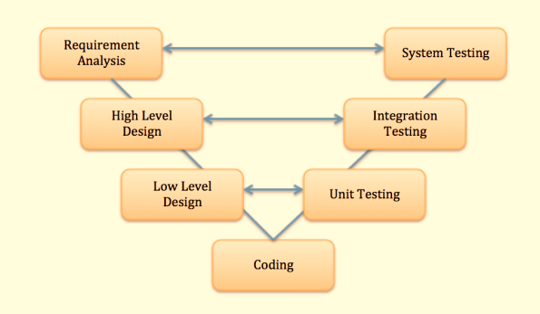

The **left side** of the model is Software Development Life Cycle - **SDLC**

The **right side** of the model is Software Test Life Cycle - **STLC**

The entire figure looks like a V, hence the name V – model

Apart from V model, there are iterative development models, where development is carried in phases, with each phase adding a functionality to the software.

Each phase comprises of its independent set of development and testing activities.

Good examples of Development lifecycles following iterative method are Rapid Application Development, **Agile Development.**

***STLC - Software Testing Life Cycle***

Software Testing Life Cycle (STLC) is defined as a ***sequence of activities conducted to perform Software Testing.***

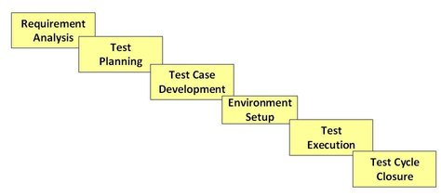

***Manual testing***

Manual Testing is a type of Software Testing where Testers **manually execute test cases** without using any automation tools.

Manual testing is the most primitive of all testing types and helps find bugs in the software system.

 Any **new application** must be **manually tested** **before** its testing can be **automated**. Manual testing requires more effort, but is **necessary to check automation feasibility.**

Manual Testing does not require knowledge of any testing tool.

One of the Software Testing Fundamental is "**100% Automation is not possible**".

This makes Manual Testing imperative.

***Goal of Manual Testing***

*The key concept of Manual Testing is to ensure that the* ***application is error free*** *and it is* ***working in conformance to the specified functional requirements.***

**Test Suites or cases**, are designed during the testing phase and should have **100% test coverage.**

It also makes sure that reported **defects** are **fixed** by developers and **re-testing** has been performed by testers on the **fixed defects.**

Basically, this testing checks the **quality of the system** and **delivers bug-free product** to the customer.

**Types of Manual Testing:**

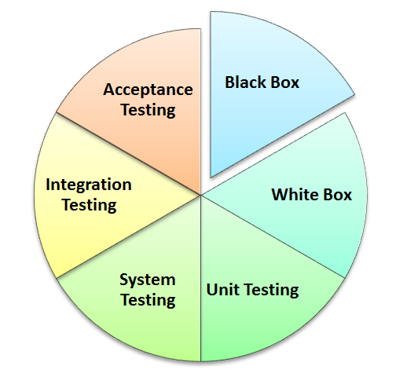

***Myths of Manual Testing***

Myth: Anyone can do manual testing

**Fact**: Testing requires many skill sets

Myth: Testing ensures 100% Defect free product

**Fact**: Testing attempts to find as many defects as possible.

Identifying all possible defects is impossible.

Myth: Automated testing is more powerful than manual testing

**Fact**: 100% test automation cannot be done. Manual Testing is also essential.

Myth: Testing is easy

**Fact**: Testing can be extremely challenging.

***Testing an application for possible use cases with minimum test cases requires high analytical skills.***

***Manual Testing vs Automation Testing***

|  |  |
| --- | --- |
| ***Manual Testing*** | ***Test Automation*** |
| Manual testing requires **human intervention for test execution.** | Test Automation is use of **tools to execute test cases** |
| Manual testing will require **skilled labour, long time & will imply high costs.** | Test Automation saves time, cost and manpower. Once recorded, it's easier to run an Test Automation suite |
| Any type of application can be tested manually, certain testing types like **ad-hoc and monkey testing** are more suited for **manual execution.** | Test Automation is recommended only for stable systems and is mostly used for **Regression Testing** |
| Manual testing can be become **repetitive and boring.** | The boring part of executing same test cases time and again, is handled by automation software in Test Automation. |

***Test Automation:***

Performs:

1. **Execute Test case suite.**
2. Enter **test data**
3. **Assert(Compare**) Actual vs Expected results.
4. Generate **Test Report.**

***“Goal of Automation is to reduce number of test cases to be run manually and not eliminate manual testing all together.”***

***Test Automation advantages :***

* No Human intervention for execution.
* increases speed of test execution
* increase Test Coverage

***Which Test Cases to Automate?***

High Risk - Business Critical test cases

Test cases that are executed repeatedly

Test Cases that are very tedious or difficult to perform manually

Test Cases which are time consuming.

The following category of ***test cases are not suitable for automation***:

Test Cases that are **newly designed** and **not executed manually at least once.**

Test Cases for which the ***requirements are changing frequently.***

Test cases which are ***executed on ad-hoc basis.***

***Test Automation Process:***

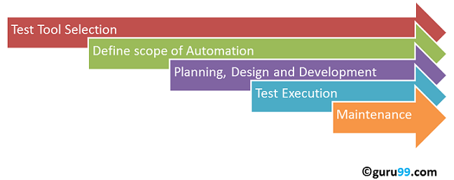

***Test tool selection***

Test Tool selection largely depends on the ***technology of the Application Under Test is built on.***

**It's a good idea to conduct Proof of Concept of Tool on AUT.**

***Define the scope of Automation***

Scope of automation is the ***area of Application Under Test which will be automated.***

points determine scope:

**Features of Business importance.**

Scenarios which have **large amount of data**

**Common functionalities** across applications

**Technical feasibility**

Extent to which **business components are reused**

**Complexity** of **test cases**

Ability to use the same test cases for cross browser testing.

***Planning, Design and Development***

During this phase, create **Automation strategy & plan,** which contains following details-

Automation tools selected

Framework design and its features

In-Scope and Out-of-scope items of automation

Automation test bed preparation

Schedule and Timeline of scripting and execution

Deliverables of Test automation.

***Test Execution***

Automation Scripts are executed during this phase. The **scripts** need **input test data** before there are set to run. Once executed they provide detailed test reports.

Execution can be performed using the automation tool directly or through the **CI/CD** which will **invoke the automation tool.**

Scripts can be executed in a single machine or a group of machines.

**Maintenance**

As new functionalities are added to the System Under Test with successive cycles, Automation Scripts need to be added, reviewed and maintained for each release cycle.

**Maintenance becomes necessary to *improve effectiveness of Automation Scripts.***

***Framework in Test Automation***

A framework is **set of automation guidelines which help in**

**Maintaining consistency of Testing**

Improves test structuring

Minimum usage of code

Less Maintenance of code

Improve re-usability

Non-Technical testers can be involved in code

Training period of using the tool can be reduced

Involves Data wherever appropriate

***Five types of framework used in automation software testing:***

Linear Automation Framework

Modular/Functional Automation Framework

Data Driven Automation Framework

Keyword Driven Automation Framework

Hybrid Automation Framework

***Test Automation Best Practices***

* **Scope of Automation** needs to be **determined** in detail **before the start of the project.** This sets expectations from Automation right.
* Select the **right automation tool:** A tool must not be selected based on its popularity but it's fit to the automation requirements.
* Choose **appropriate framework.**
* **Scripting Standards-** Standards have to be followed while writing the scripts for Automation. Some of them are-

Create ***uniform scripts, comments and indentation of the code***

**Adequate Exception handling** - How error is handled on system failure or unexpected behaviour of the application.

**User defined messages** should be coded or standardized for **Error Logging for testers to understand.**

**Measure metrics-** Success of automation can be determined by capturing the following metrics.

**Percent of defects found**

**Time required for automation testing for each and every release cycle**

Minimal Time taken for release

**Customer/End user satisfaction Index**

Productivity improvement.

***Benefits of Automation Testing***

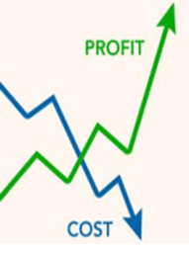

70% faster than the manual testing

Wider test coverage of application features

Reliable in results

Ensure Consistency

Saves Time and Cost

Improves accuracy

Human Intervention is not required while execution

Increases Efficiency

Better speed in executing tests

Re-usable test scripts

Test Frequently and thoroughly

More cycle of execution can be achieved through automation

Early time to market

Increased ROI

***How to Choose an Automation Tool?***

Environment Support

Ease of use

Testing of Database

Object identification

Image Testing

Error Recovery Testing

Object Mapping

Scripting Language Used

Support for various types of test - including functional, test management, mobile, etc...

Support for multiple testing frameworks

Easy to debug the automation software scripts

Ability to recognize objects in any environment

Extensive test reports and results

Minimize training cost of selected tools

** Identify the requirements, explore various tools and its capabilities, set the expectation from the tool and go for a Proof of Concept.

Conclusion

Right selection of Test Automation tool, testing process and team, are important players for automation to be successful. Manual and automation methods go hand-in hand for successful testing.

***Software Test types (basic):***

***Functional :***

1. ***UNIT Testing***

Unit testing of software applications is done during the development (**coding**) of an application.

The objective of unit testing is to isolate a section of code and verify its correctness.

In procedural programming, a unit may be an individual function or procedure.

***How to Create Unit Test Cases?***

Unit testing is commonly automated, but may still be performed manually.

The IEEE does not favour one over the other.

A manual approach to unit testing may employ a step-by-step instructional document.

Under the automated approach-

A developer could write another section of code in the application just to test the function. They would later comment out and finally remove the test code when the application is done.

They could also isolate the function to test it more rigorously. This is a more thorough unit testing practice that involves copy and pasting the function from its own testing environment to other than its natural environment.

Isolating the code helps in revealing unnecessary dependencies between the code being tested and other units or data spaces in the product.

These dependencies can then be eliminated.

A coder may use a Unit Test Framework to develop automated test cases.

Using an automation framework, the developer codes criteria into the test to verify the correctness of the unit.

During execution of the test cases, the framework logs those fail any criteria.

Many frameworks will also automatically flag and report in a summary these failed test cases.

Depending upon the severity of a failure, the framework may halt subsequent testing.

**Mock Objects**

Unit testing relies on mock objects being created to test sections of code that are not yet part of a complete application.

***Mock objects fill in for the missing parts of the program.***

For example, you might have a function that needs variables or objects that are not created yet. In unit testing, those will be accounted for in the form of mock objects created solely for the purpose of the unit testing done on that section of code.

***Unit Testing Benefits and Advantage:***

Developers looking to learn what functionality is provided by a unit and how to use it can look at the unit tests to gain a *basic understanding of the unit API.*

Unit testing allows the programmer to refactor code at a later date, and make sure the module still works correctly.

The procedure is to write test cases for all functions and methods so that whenever a change causes a fault, it can be quickly identified and fixed.

Due to the modular nature of the unit testing, we can test parts of project without waiting for others to be completed.

**Unit Testing Limitations**

Unit testing can't be expected to catch every error in a program.

It is **not possible to evaluate all execution paths** even in the most trivial programs.

Unit testing by its very nature focuses on a unit of code. Hence it can't catch integration errors or broad system level errors.

***Unit Testing Techniques***

1. Structural Techniques
2. Functional Testing Techniques
3. Error Based Techniques

***Unit Testing Best Practices:***

Unit Test cases should be **independent**.

In case of any enhancements or change in requirements, unit test cases should not be affected.

Test only **one code at a time.**

Follow **clear and consistent naming conventions** for your unit tests.

In case of change in code in any module, ensure there is a corresponding unit Test Case for the module and the **module passes the tests before changing the implementation**

Bugs identified during unit testing must be fixed before proceeding to the next phase in SDLC.

Adopt a "**test as you code"** approach. The more code you write without testing the more paths you have to check for errors.

***INTEGRATION Testing: Big Bang, Top Down & Bottom Up***

In Integration Testing, ***individual software modules are integrated logically and tested as a group.***

A typical software project consists of multiple software modules, coded by different programmers.

Integration testing focuses on checking **data communication** amongst these **modules**.

Hence it is also termed as **'I & T'** (Integration and Testing), **'String Testing'** and sometimes **'Thread Testing'.**

***Why do Integration Testing is required?***

Although each software module is unit tested, defects still exist for various reasons like A Module in general is designed by an individual software developer whose understanding and programming logic may differ from other programmers.

Integration testing becomes necessary to ***verify the software modules work in unity.***

At the time of module development, there are wide chances of change in requirements by the clients. These new requirements may not be unit tested and hence system integration testing becomes necessary.

**Interfaces of the software modules with the database** could be erroneous

**External Hardware interfaces**, if any, could be erroneous

**Inadequate exception handling could cause issues.**

***Integration Test Case:***

Integration Test Case differs from other test cases in the sense it**focuses mainly on the interfaces & flow of data/information between the modules**. Here priority is to be given for the **integrating links** rather than the unit functions which are already tested.

|  |  |  |  |
| --- | --- | --- | --- |
| Test Case ID | Test Case Objective | Test Case Description | Expected Result |

***Approaches/Methodologies/Strategies of Integration Testing:***

***Big Bang Approach***:

Here all component are integrated together at **once**, and then tested.

**Advantages:**

Convenient for small systems.

**Disadvantages:**

Fault Localization is difficult.

Given the sheer number of interfaces that need to be tested in this approach, some interfaces links to be tested could be missed easily.

Since the integration testing can commence only after "all" the modules are designed, testing team will have less time for execution in the testing phase.

Since all modules are tested at once, high risk critical modules are not isolated and tested on priority. Peripheral modules which deal with user interfaces are also not isolated and tested on priority.

***Incremental Approach:***

In this approach, testing is done by joining two or more modules that are **logically related**. Then the other related modules are added and tested for the proper functioning. Process continues until all of the modules are joined and tested successfully.

This process is carried out by using dummy programs called **Stubs and Drivers**. Stubs and Drivers do not implement the entire programming logic of the software module but just **simulate data communication** with the calling module.

**Stub**: Is called by the Module under Test.

**Driver**: Calls the Module to be tested.

Incremental Approach in turn is carried out by two different Methods:

**Bottom Up**

**Top Down**

***Bottom up Integration***

In the bottom up strategy, each module at lower levels is tested with higher modules until all modules are tested. It takes help of Drivers for testing

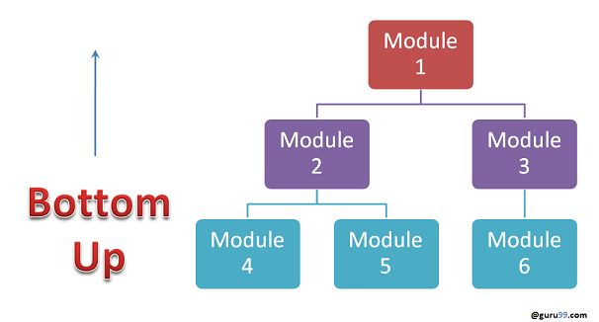

Advantages:

Fault localization is easier.

No time is wasted waiting for all modules to be developed unlike Big-bang approach

Disadvantages:

Critical modules (at the top level of software architecture) which control the flow of application are tested last and may be prone to defects.

Early prototype is not possible

Top down Integration:

In Top to down approach, testing takes place from top to down following the control flow of the software system.

Takes help of stubs for testing.

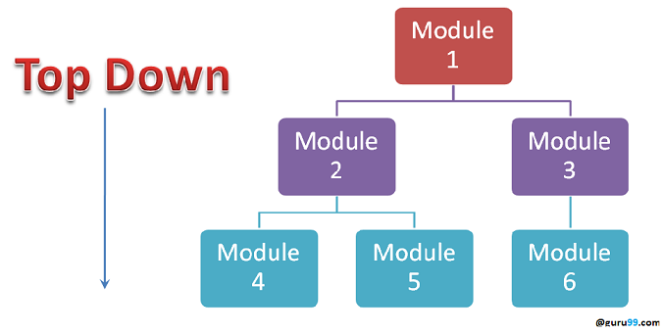

Advantages:

Fault Localization is easier.

Possibility to obtain an early prototype.

Critical Modules are tested on priority; major design flaws could be found and fixed first.

Disadvantages:

Needs many Stubs.

Modules at lower level are tested inadequately.

***Integration Testing Procedure***

(The integration test procedure irrespective of the test strategies) :

1. **Prepare the Integration Tests Plan**
2. **Design the Test Scenarios, Cases, and Scripts.**
3. **Executing the test Cases followed by reporting the defects.**
4. **Tracking & re-testing the defects.**

Above 2 steps are repeated until the completion of Integration is successfully.

***Brief Description of Integration Test Plans:***

* **Methods/Approaches to test** (as discussed above).
* **Scopes and Out of Scopes Items** of Integration Testing.
* **Roles and Responsibilities.**
* **Pre-requisites** for Integration testing.
* **Testing environment**.
* **Risk and Mitigation Plans.**

***Entry and Exit Criteria:***

***Entry Criteria:***

Unit Tested Components/Modules

All High prioritized bugs fixed and closed

All Modules to be code completed and integrated successfully.

Integration tests Plan, test case, scenarios to be signed off and documented.

Required Test Environment to be set up for Integration testing

***Exit Criteria:***

Successful Testing of Integrated Application.

Executed Test Cases are documented

All High prioritized bugs fixed and closed

Technical documents to be submitted followed by release Notes.

***Best Practices/ Guidelines for Integration Testing***

* First **determine** the **Integration Test Strategy** that could be adopted and later prepare the **test cases** and **test data** accordingly.
* Study the **Architecture design** of the Application and identify the **Critical Modules**. These need to be tested on priority.
* Obtain the **interface designs** from the **Architectural team** and create **test cases** to **verify all of the interfaces** in detail.

***Interface to database/external hardware/software application*** must be tested in detail.

After the test cases, it's the test data which plays the critical role.

Always have the **mock data** prepared, **prior to executing**.

***Do not select test data while executing the test cases.***

***What is System Testing?***

System testing is the testing of a complete and fully integrated software product.

Usually software is only one element of a larger computer based system. Ultimately, software is interfaced with other software/hardware systems.

System testing is actually a series of different tests whose sole purpose is to exercise the full computer based system.

System test falls under the black box testing category of software testing.

System test involves the external workings of the software from the user's perspective.

System testing involves testing the software code for following

**Testing the fully integrated applications** including external peripherals in order to check how components interact with one another and with the system as a whole. This is also called End to End testing.

Verify thorough testing of every input in the application to check for desired outputs.

Testing of the user's experience with the application.

That is a very basic description of what is involved in system testing. You need to build detailed test cases and test suites that test each aspect of the application as seen from the outside without looking at the actual source code.

**Software Testing Hierarchy**

The following is a list of software testing categories arranged in chronological order.

**Unit testing -** testing performed on each module or block of code during development. Unit Testing is normally done by the programmer who writes the code.

**Integration testing -** testing done before, during and after integration of a new module into the main software package. This involves testing of each individual code module. One piece of software can contain several modules which are often created by several different programmers. It is crucial to test each module's effect on the entire program model.

**System testing -** testing done by a professional testing agent on the completed software product before it is introduced to the market.

**Acceptance testing -** beta testing of the product done by the actual end users.

**Sanity Testing Vs Smoke Testing:**

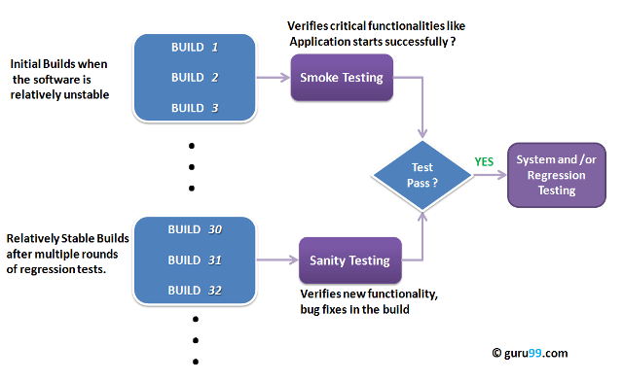

**What is Smoke Testing?**

Smoke Testing is a kind of Software Testing performed after software build to ascertain that the critical functionalities of the program is working fine. It is executed "before" any detailed functional or regression tests are executed on the software build. The purpose is to reject a badly broken application, so that the QA team does not waste time installing and testing the software application.

In Smoke Testing, the test cases chosen cover the most important functionality or component of the system. The objective is not to perform exhaustive testing, but to verify that the critical functionalities of the system is working fine.  
For Example a typical smoke test would be - Verify that the application launches successfully, Check that the GUI is responsive ... etc.

**What is Sanity Testing?**

Sanity testing is a kind of Software Testing performed after receiving a software build, with minor changes in code, or functionality, to ascertain that the bugs have been fixed and no further issues are introduced due to these changes. The goal is to determine that the proposed functionality works roughly as expected. If sanity test fails, the build is rejected to save the time and costs involved in a more rigorous testing.

The objective is "not" to verify thoroughly the new functionality, but to determine that the developer has applied some rationality (sanity) while producing the software.

**Smoke Testing Vs Sanity Testing - Key Differences**

|  |  |
| --- | --- |
| **Smoke Testing** | **Sanity Testing** |
| Smoke Testing is performed to ascertain that the critical functionalities of the program is working fine | Sanity Testing is done to check the new functionality / bugs have been fixed |
| The objective of this testing is to verify the "stability" of the system in order to proceed with more rigorous testing | The objective of the testing is to verify the "rationality" of the system in order to proceed with more rigorous testing |
| This testing is performed by the developers or testers | Sanity testing is usually performed by testers |
| Smoke testing is usually documented or scripted | Sanity testing is usually not documented and is unscripted |
| Smoke testing is a subset of Regression Testing | Sanity testing is a subset of Acceptance testing |
| Smoke testing exercises the entire system from end to end | Sanity testing exercises only the particular component of the entire system |
| Smoke testing is like General Health Check Up | Sanity Testing is like specialized health check up |

**Points to note.**

Both sanity tests and smoke tests are ways to avoid wasting time and effort by quickly determining whether an application is too flawed to merit any rigorous testing.

Sanity Testing is also called tester acceptance testing.

Smoke testing performed on a particular build is also known as a build verification test.

One of the best industry practice is to conduct a Daily build and smoke test in software projects.

Both smoke and sanity tests can be executed manually or using an automation tool.  When automated tools are used, the tests are often initiated by the same process that generates the build itself.

As per the needs of testing, you may have to execute both Sanity and Smoke Tests on the software build. In such cases, you will first execute Smoke tests and then go ahead with Sanity Testing. In industry, test cases for Sanity Testing are commonly combined with that for smoke tests, to speed up test execution. Hence, it's a common that the terms are often confused and used interchangeably.

**Software Quality:**

Software quality is the degree of conformance to explicit or implicit requirements and expectations.

Explicit: clearly defined and documented

Implicit: not clearly defined and documented but indirectly suggested

Requirements: business/product/software requirements

Expectations: mainly end-user expectations

Definition by IEEE

The degree to which a system, component, or process meets specified requirements.

The degree to which a system, component, or process meets customer or user needs or expectations.

Definition by ISTQB

quality: The degree to which a component, system or process meets specified requirements and/or user/customer needs and expectations.

software quality: The totality of functionality and features of a software product that bear on its ability to satisfy stated or implied needs.

As with any definition, the definition of ‘software quality’ is also varied and debatable. Some even say that ‘quality’ cannot be defined and some say that it can be defined but only in a particular context. Some even state confidently that ‘quality is lack of bugs’. Whatever the definition, it is true that quality is something we all aspire to.

Software quality has many dimensions.

**Dimensions of Software Quality:**

Accessibility: The degree to which software can be used comfortably by a wide variety of people, including those who require assistive technologies like screen magnifiers or voice recognition.

Compatibility: The suitability of software for use in different environments like different Operating Systems, Browsers, etc.

Concurrency: The ability of software to service multiple requests to the same resources at the same time.

Efficiency: The ability of software to perform well or achieve a result without wasted energy, resources, effort, time or money.

Functionality: The ability of software to carry out the functions as specified or desired.

Install ability: The ability of software to be installed in a specified environment.

Localizability: The ability of software to be used in different languages, time zones etc.

Maintainability: The ease with which software can be modified (adding features, enhancing features, fixing bugs, etc)

Performance: The speed at which software performs under a particular load.

Portability: The ability of software to be transferred easily from one location to another.

Reliability: The ability of software to perform a required function under stated conditions for stated period of time without any errors.

Scalability: The measure of software’s ability to increase or decrease in performance in response to changes in software’s processing demands.

Security: The extent of protection of software against unauthorized access, invasion of privacy, theft, loss of data, etc.

Testability: The ability of software to be easily tested.

Usability: The degree of software’s ease of use.

**Software Quality Assurance**

Software Quality Assurance (SQA) is a set of activities for ensuring quality in software engineering processes (that ultimately result in quality in software products).

It includes the following activities:

Process definition and implementation

Auditing

Training

Processes could be:

Software Development Methodology

Project Management

Configuration Management

Requirements Development/Management

Estimation

Software Design

Testing

etc

Once the processes have been defined and implemented, Quality Assurance has the following responsibilities:

identify weaknesses in the processes

correct those weaknesses to continually improve the process

The quality management system under which the software system is created is normally based on one or more of the following models/standards:

* **CMMI**
* **Six Sigma**
* **ISO 9000**

Note: There are many other models/standards for quality management but the ones mentioned above are the most popular.

Software Quality Assurance encompasses the entire software development life cycle and the goal is to ensure that the development and/or maintenance processes are continuously improved to produce products that meet specifications/requirements.

The process of Software Quality Control (SQC) is also governed by Software Quality Assurance (SQA).

SQA is generally shortened to just QA.

**Software Quality Control**

SOFTWARE QUALITY CONTROL Fundamentals

Software Quality Control (SQC) is a set of activities for ensuring quality in software products.

It includes the following activities:

Reviews

Requirement Review

Design Review

Code Review

Deployment Plan Review

Test Plan Review

Test Cases Review

Testing

Unit Testing

Integration Testing

System Testing

Acceptance Testing

Software Quality Control is limited to the Review/Testing phases of the Software Development Life Cycle and the goal is to ensure that the products meet specifications/requirements.

The process of Software Quality Control (SQC) is governed by Software Quality Assurance (SQA). While SQA is oriented towards prevention, SQC is oriented towards detection.

***Requirements Traceability Matrix***

Table shows **Requirements/Use cases to Test Cases** relationship.

Business requirements > Software requirements >System Architecture >Design Specifications > Test Cases > Automated Test Scripts

Forward and Backward Traceability.

RTM – 100% Test Coverage.

Reference Docs – BRD, FRD, TDD / Use Case / Wireframes / Documented in a meeting.

***Test Scenarios – intermediaries between requirements and Test Cases.***

**< Wireframes** - A basic visual representation of a website (Web Services) /highlights the functional aspects and APIs of a web App. It won’t focus on UI aspects much / It establishes a hierarchy of info. Simplifies Communications & as a Visual Blueprint of a Web App. >

***Test Strategy***

*Test Strategy defines the outline of an approach of **testing an Application**.

Test Strategy describes the level of Testing 🡪 Primarily 3 levels – Unit, Integration, System.

Test Strategy notifies Risks and Mitigations.

Test Strategy has to be approved by both Test Manager and Development Managers before testing begins.

Created based on Development Design Documents and System Design Document.

It defines **Entry and Exit criteria for the complete Project.**

***Test Plan***

Day to day activities.

Usually written by one person with consent from Team members.

Test Plan Doc. (by QA Team)

🡪 **Scope** – define the boundaries / Test Scenarios / Test Objectives are validated.

* **Out of Scope** – Enhanced clarity on what is not covered.
* **Assumptions** – Prerequisites needed by QA to go ahead for Testing
* **Schedules** – Test Scenario Preparation / Test Documentation – Test Case, Test Data Creation, Test Environment Set up. / Test Execution /Test Cycle

Start and End date for Testing.

Mile Stone Documentation.

* **Roles & Responsibilities** - Team Members Details. / who is to do what?
* **Deliverables** – What docs (Test Artefacts) are delivered at What time?
* **Environment** – who is in charge? What to do in case of issues?
* **Tools**
* **Defect Management** – Defect Tracking and Flow Chart. / Reporting Process.
* **Risk and Risk Management** – Mitigation Aspects of Risks.
* **Exit Criteria** – when to stop Testing.

* Test Plan talks about – What, When, How to Test, in which Environment, Tools Used, What Data to Use, Resources and Risk Management.

***Software Test case creation / Generation***

** A test case is a document with User Actions and response (expected result) to it.

Test case writing techniques: Black box techniques. (Normally) / Normally written in excel sheet.

To write Test Cases effectively 🡪

Rules: **Naming conventions for Test Case ID.**

**Simple and Comprehensive**

**Positive (Valid data) and Negative (Invalid data) Test cases.**

Write / Understandable / Run / change, maintain

* Test Case Template is customizable.

|  |  |  |  |
| --- | --- | --- | --- |
| **Test Case ID** | **Test Case Objective** | **Test Case Description** | **Expected Result** |

|  |  |  |  |  |  |  |
| --- | --- | --- | --- | --- | --- | --- |
| **Test Case ID** | **Steps** | **Test Data** | **Expected Result** | **Actual Result** | **Status**  **<Not Executed /Blocked /Fail /**  **Pass** | **Comments** |
| **ProjectName**  **_ModuleName**  **_Functionality**  **_TestScenario**  **_SerialNumber** |  |  |  |  |  |  |

**\*Hierarchy of Testing Activities in a SDLC:**

Application 🡪 Project 🡪 Requirements <High Level> 🡪 Requirements <low Level> 🡪 **Testable** Requirements 🡪 Test Functionalities 🡪 Test Scenarios 🡪Test Cases

(Test Data), (Test Scripts)🡪 Health Check 🡪Exit Report.

***Test Design Techniques:***

To achieve maximum test coverage with minimum (optimal) Test cases.

**Equivalence Class Partitioning:** in Unit, System & Functional Testing Divide Test Data in to Parts.

Valid and Invalid Partitions.

**Boundary Value Analysis:** Test on either side of the boundary.

**Decision Table:** A Black Box Design Technique to determine the Test Scenarios for complex business logic. / also known as **Cause Effect Table.**

Input Data is chosen from Data Set / Combinations based on some logical conditions.

To document complex logic / Test all combinations of conditions / CONDITIONS & ACTIONS.

**Use Case Testing:**

Use Case – A list of steps to achieve a goal in the system / Steps define the interactions between the actor and the system. /Use case captures the functional requirements of the system / It defines the outcomes of the error during System use. / has 2 parts –Main scenarios and Optional Exceptional Scenarios.

< scenarios – Workflow / Sequence of events>

Use Case Testing - Review the Use Case / write Test Cases for both Normal and alternate Work flow.

***Test Case Management***

Use Test Management Tools for Test Case Management.

***Test Data Generation***

Input and Output Test Data

Created on the fly and designed before Test

Valid Test Data / No Test Data / Invalid Test Data

Whole Range of Test Data

System Configuration Data – ex: Connection Strings / Default Settings / Server access Settings

System Data – Menus / Products

Transaction Data – output from user actions.

**Software Testing Metrics**

**Software Testing Metrics** are the quantitative measures used to estimate the progress, quality, productivity and health of the software testing process.

The goal of software testing metrics is to improve the efficiency and effectiveness in the software testing process and to help make better decisions for further testing process by providing reliable data about the testing process.

A Metric defines in quantitative terms the degree to which a system, system component, or process possesses a given attribute.

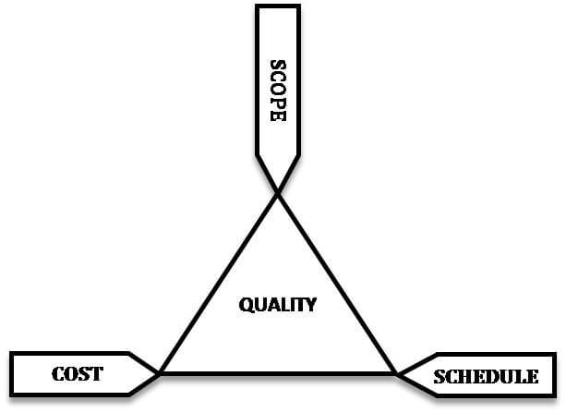

Software testing metrics or software test measurement is the quantitative indication of extent, capacity, dimension, amount or size of some attribute of a process or product.

## Why Test Metrics are Important?

"We cannot improve what we cannot measure" and Test Metrics helps us to do exactly the same.

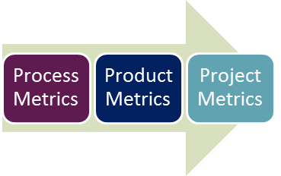

* **Process Metrics:** It can be used to improve the process efficiency of the SDLC ( Software Development Life Cycle)
* **Product Metrics:** It deals with the quality of the software product
* **Project Metrics:** It can be used to measure the efficiency of a project team or any testing tools being used by the team members

things need to be considered before identifying the test metrics

* Fix the target audience for the metric preparation
* Define the goal for metrics
* Introduce all the relevant metrics based on project needs
* Analyze the cost benefits aspect of each metrics and the project lifestyle phase in which it results in the maximum output
* 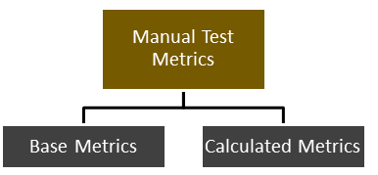

Base metrics is the raw data collected by Test Analyst during the test case development and execution (**# of test cases executed, # of test cases**). While calculated metrics are derived from the data collected in base metrics. Calculated metrics is usually followed by the test manager for test reporting purpose (**% Complete, % Test Coverage**).

**Performance testing** is the process of determining the speed, responsiveness and stability of a computer, network, software program or device under a workload. ... Typical parameters include processing speed, data transfer rate, network bandwidth and throughput, workload efficiency and reliability.

## **Attributes of Performance Testing:**

* Speed
* Scalability
* Stability
* reliability

## **Performance Testing Techniques:**

* **Load testing -**It is the simplest form of testing conducted to understand the behaviour of the system under a specific load. Load testing will result in measuring important business critical transactions and load on the database, application server, etc., are also monitored.
* **Stress testing -**It is performed to find the upper limit capacity of the system and also to determine how the system performs if the current load goes well above the expected maximum.
* **Soak testing -**Soak Testing also known as endurance testing, is performed to determine the system parameters under continuous expected load. During soak tests the parameters such as memory utilization is monitored to detect memory leaks or other performance issues. The main aim is to discover the system's performance under sustained use.
* **Spike testing -**Spike testing is performed by increasing the number of users suddenly by a very large amount and measuring the performance of the system. The main aim is to determine whether the system will be able to sustain the workload.

pen test and vulnerability assessment

A **penetration test**, or **pentest**, is the manual process where an ethical hacker conducts an **assessment** on a target to uncover **vulnerabilities** by exploiting them. The goal is to gain unauthorized access through exploitation which can be used to emulate the intent of a malicious hacker.

vulnerability assessment

evaluates if the system is susceptible to any known **vulnerabilities**, assigns severity levels to those **vulnerabilities**, and recommends remediation or mitigation, if and whenever needed. Examples of threats that can be prevented by **vulnerability assessment** include: SQL injection, XSS and other code injection attacks.